Sprint-1 Delivery

**CREATE HTML FILES**

|  |  |
| --- | --- |
| Date | 31 Oct 2022 |
| Team ID | PNT2022TMID48082 |
| Project Name | Smart Waste Management System For Metropolitan Cities |

**TASK:**

***We use HTML to create the front end part of the web page.***

**HTML CODE FOR LOGIN PAGE:**

<!DOCTYPE html>

<html>

<head>

<meta name="viewport" content="width=device-width, initial-scale=1">

<title> Login Page </title>

<style>

Body {

font-family: palatino, Helvetica, sans-serif;

background-color: MediumSeaGreen;

}

button {

background-color: #4CAF50;

width: 100%;

color: white;

padding: 15px;

margin: 10px 0px;

border: dotted solid;

cursor: pointer;

}

form {

border: 3px solid #90EE90;

}

input[type=text], input[type=password] {

width: 100%;

margin: 8px 0;

padding: 12px 20px;

display: inline-block;

border: 2px solid green;

box-sizing: border-box;

}

button:hover {

opacity: 0.7;

}

.cancelbtn {

width: auto;

padding: 10px 18px;

margin: 10px 5px;

}

.container {

padding: 25px;

background-color: PaleGreen;

}

</style>

</head>

<body>

<center> <h1>LOGIN FORM </h1> </center>

<form>

<div class="container">

<label>Username : </label>

<input type="text" placeholder="Enter Username" name="username" required>

<label>Password : </label>

<input type="password" placeholder="Enter Password" name="password" required>

<button type="submit">Login</button>

<input type="checkbox" checked="checked"> Remember me

<button type="button" class="cancelbtn"> Cancel</button>

<a href="#"> Forgot password? </a>

</div>

</form>

</body>

</html>

**LOGIN PAGE(SCREEN SHOT):**

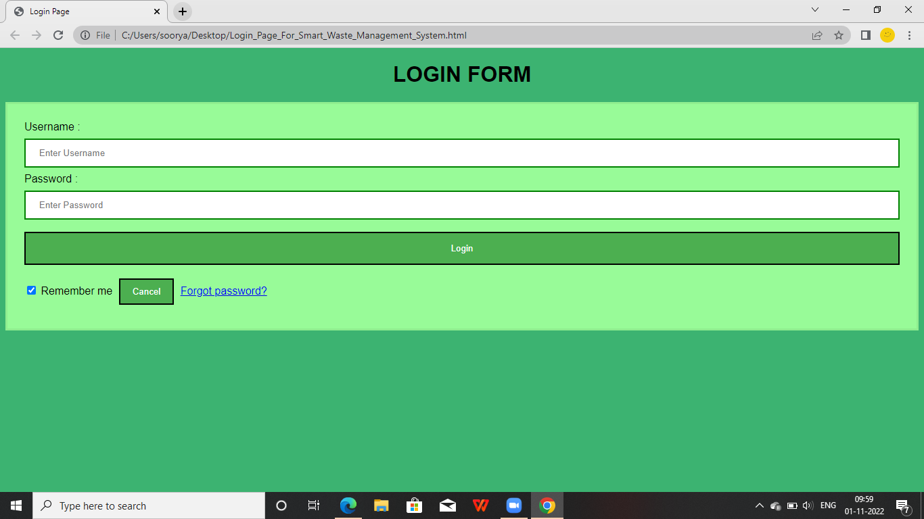

**HTML CODE FOR REGISTRATION:**

<!DOCTYPE html>

<html>

<head>

<title></title>

<meta name="viewport" content="width=device-width, initial-scale=1.0">

<link rel="stylesheet" type="text/css" href="CSS\styleregisterdonor.css">

<link rel="stylesheet" href="https://cdnjs.cloudflare.com/ajax/libs/font-awesome/4.7.0/css/font-awesome.min.css">

<!-- jQuery library -->

<script src="https://ajax.googleapis.com/ajax/libs/jquery/3.2.1/jquery.min.js"></script>

<!-- Latest compiled JavaScript -->

<script src="https://maxcdn.bootstrapcdn.com/bootstrap/3.3.7/js/bootstrap.min.js"></script>

<script src="https://www.google.com/recaptcha/api.js" async defer></script>

<style type="text/css">

.error

{

color: red;

}

</style>

</head>

<body>

<?php

include 'header.php';

?>

<div class="heading fix">

<label>REGISTRATION</label>

</div>

<div class="outerbox">

<div class="fixedbox">

<span class="content">

<h4>Hello, Friend!</h4>

<p>Enter your personal details and start journey with us</p>

</span>

</div>

<div class="scrollbox">

<div class="registerdonor">

<form action="process.php" method="POST" id="myform">

<div class="login">

<h3>Login Details</h3>

<table>

<tr>

<td colspan="2">

<label class="username">User Name:-</label>

<input type="text" name="user_name" required pattern="^[A-Za-z0-9._%+-@]{5,10}$" title="Enter a username between 5 to 10 letter" autocomplete="off">

</td>

</tr>

<tr>

<td>

<label>Full Name:-</label>

<input type="text" name="user_full_name" required pattern="[A-z ]+$" title="Use only character & whitespace" autocomplete="off">

</td>

<td>

<label>Email Id:-</label>

<input type="email" name="user_email" required pattern="[A-Za-z0-9._%+-]+@[A-z0-9.-]+\.[a-z]{2,}$" title="Email id is not Valid" autocomplete="off">

</td>

</tr>

<tr>

<td>

<label>Password:-</label>

<input type="password"name="password" required pattern="(?=.\d)(?=.[a-z])(?=.*[A-Z]).{6,}" title="Must contain at least one number and one uppercase and lowercase letter, and at least 6 or more characters" id="password" autocomplete="off">

</td>

<td>

<label>Confirm Password:-</label>

<input type="text" name="confirm_password" required pattern="(?=.\d)(?=.[a-z])(?=.*[A-Z]).{6,}" title="Must contain at least one number and one uppercase and lowercase letter, and at least 6 or more characters" id="confirm_password" autocomplete="off">

</td>

</tr>

</table>

</div>

<div class="contact">

<h3>Contact Details</h3>

<table>

<tr>

<td>

<label>Mobile Number:-</label>

<input type="text" name="user_number" required pattern="^[1-9]{1}[0-9]{9}$" title="Number is not valid" autocomplete="off">

</td>

<td rowspan="2">

<label>Address:-</label>

<textarea name="Address" placeholder="---Type---" required></textarea>

</td>

</tr>

<tr>

<td>

<label>Pincode</label>

<input type="text" name="pincode" required pattern="^[0-9]{6}$" title="Pincode is not valid" autocomplete="off">

</td>

</tr>

<tr>

<td>

<label>City:-</label>

<input type="text" name="city" >

</td>

<td>

<label>State:-</label>

<input type="text" name="state">

</td>

</tr>

</table>

</div>

<span>

<input type="checkbox" name="terms" id="checkbox" required autocomplete="off">

</span><p>I agree to have my contact details broadcasted to the registered municipality admin </p>

<div class="btn">

<input type="submit" name="submit" value="Submit">

<input type="reset" name="submit" value="Reset">

</div>

</form>

</div>

</div>

</div>

<!-- Responsive Table -->

<div class="rregisterdonor">

<form action="process.php" method="POST" id="myform">

</html>

**REGISTRATION FORM(SCREEN SHOT):**

